PRIMARY SIX SOCIAL STUDIES
AND
CHRISTIAN RELIGIOUS EDUCATION
LESSON NOTES
AND SCHEMES
TERM II,
2023

MAJOR RESOURCES IN EAST AFRICA
Vocabulary
- Resource - utilization
- Natural resources - preservation
- Renewable - degradation
- Non-renewable resources - conservation
- Exploitation - extraction
- Minerals - mining
- Poaching
RESOURCES
- What is a resource?
A resource is anything that people use to meet their needs.
- Types of resources
- Natural resources
- Man-made resources
- Natural resources
These are things that exist on their own and are useful to people.
- Examples of natural resources in East Africa
- Land
- Water bodies/water
- Vegetation/forests
- Climate/weather/air
- Animals
- Human beings/people
- Minerals
- Types of natural resources
- Renewable resources
- Non-renewable resources
- What are renewable resources?
These are resources that can’t be used up.
- Examples of renewable resources
- Land
- Water bodies/water
- Vegetation/forests
- Climate/weather/air
- Animals/wildlife
- Human beings/people

- What are non-renewable resources?
These are resources that can be used up.
- Examples of non-renewable resources.
- Minerals, e.g.
- gold
- crude oil
- copper
- limestone
- cobalt
- phosphates
- silver
- tin
- Give examples of non-export resources in East Africa.
- Land
- Climate
- Water bodies
Land as a Natural Resource
- How is land used as a resource?
- Land is used farming
- Land is used for road construction
- Land is used for mining
- Land is used for industrialization
- Land is used for settlement
- Why is land called a renewable resource?
Land cannot be used up.
- State the problems faced by land.
- Land fragmentation
- Over cultivation
- Soil exhaustion
- Pollution
- Soil erosion
- What is land fragmentation?
This is the division of land into small plots/parts.
- What causes land fragmentation?
- High population
- Highland areas
- Areas where land fragmentation is common
- Mountainous/hilly areas (Areas around Mt. Rwenzori, Mt. Elgon, Mt. Mufumbiro)
- Urban areas

- How has land fragmentation affected some communities in Uganda?
- It has led to land disputes
- It has led to low food production
- It has led to development of slums in towns
- What is land degradation?
This is the lowering of the quality of land.
- State the different ways land is degraded.
- Through over cultivation
- Through over grazing
- Through brick making
- Through swamp drainage
- Through road construction
- Through poor disposal of waste
ACTIVITY:

To visit any nearby community and see how people use land to satisfy their needs.
Read about natural resources in Fountain SST book 6.

Exercise
- What is land pollution?
This is the contamination of land.
- State one way of controlling land pollution
- In which two ways are wastes managed in our community?
- By recycling
- By using waste paper bags
- By using dust bins
- By using rubbish pits
- Mention the two different types of resources.
- Give any two examples of renewable resources.
- What is land fragmentation?
- State the major cause of land fragmentation.
- How is land used as an economic resource?
- State the reasons as to why East African countries have failed to fully exploit their natural resources

Farming in East Africa
Vocabulary
- Subsistence - dairy farming
- Arable - pastoralism
- Livestock - Horticulture - nomadism
- Floriculture - viticulture
- Perennial - apiculture
- Apiary - annual
- Ranching - plantation
- Commercial - mixed farming - agriculture

Farming
Farming is the growing of crops and rearing of animals

Farming Systems in East Africa
Subsistence farming
- What is subsistence farming?
This is the growing of crops and rearing of animals mainly for home use and the surplus for sale.
- Why do most people carry out subsistence farming in East Africa?
- It is cheap to manage.
- It doesn’t require a large piece of land.
- It doesn’t require skilled labour.
- It requires simple tools (hand tools e.g. hand hoe)
- What are some of the disadvantages of subsistence farming?
- It earns little or no income to the farmers
- The farmer gets low yields
- It doesn’t promote the growth of agro based industries
- How do agro-based industries support farming?
- How does farming support agro-based industries?

Mixed farming
- What is mixed farming?
This is the growing of crops and the rearing of animals on the same piece of land at the same time.
- How is mixed farming an advantage to those who practice it?
- A farmer gets a double income from both animals and crops.
- There is interdependence as the animals provide manure to crops and the crops provide food to animals.
125
- Disadvantages of mixed farming
- It is expensive to manage
- It requires a large piece of land
- The animals can destroy the crops on the farm

Exercise
- Why is mixed farming not commonly done by many people?
- How does a mixed farmer get a double income?
A farmer gets income through sale of plant products and animal products.
- What is arable farming?
This is the growing of crops only
- How different is horticulture from floriculture?
Horticulture is the growing of fruits, vegetables and flowers for sale while floriculture is the growing of flowers for sale.
- What is the difference between subsistence farming and commercial farming?
Subsistence farming is mainly for home consumption while commercial is mainly done for income

Plantation farming
- What is plantation farming?
This is the growing of a single perennial crop on a very large piece of land for sale
- Why is plantation farming not commonly practiced in East Africa?
- It is expensive to maintain
- It requires a lot of both skilled and unskilled labour
- It requires a big piece of land that may not be available
- It requires big machinery
- It needs big capital to start
- Advantages of plantation farming
- They create employment opportunities for people
- They provide raw materials for the industries
- They lead to development of infrastructure
- They provide market for the out growers
- A lot of income is earned by the farmers
- They encourage land consolidation
- Disadvantages of plantation farming
- It is expensive to maintain
- It requires skilled labour
- It leads to soil exhaustion
- In case of pests and natural disaster, a farmer loses a lot
- It reduces on the land for settlement and agriculture
Exercise
- Who are out-growers?
Farmers around a plantation who grow the same crop on a small scale
- What are perennial crops?
These are crops that take more than one year to mature.
- Mention the examples of crops grown on plantation farms.
- Sugarcanes
- Coffee
- Bananas
- Tea
- Cocoa
- Oil palm
- What is the difference between traditional and non-traditional cash crops?
Traditional cash crops are crops grown for sale while non-traditional cash crops are crops grown for food and sale.
- Give four examples of traditional cash crops.
- Coffee
- Tea
- Cotton
- Tobacco
- List down examples of non-traditional; cash crops
Maize millet rice
Cassava beans sweet potatoes
- Mention the factors that favour the growing of crops.
- Climate
- Fertile soils
- Relief
- Capital
- Labour
- Market
- How can the East African governments promote food production?
- By encouraging people to grow a lot of food crops
- By encouraging farmers to irrigate their crops
- By encouraging farmers to store food during the dry season
- Mention the factors that promote commercial farming.
- Capital
- Skilled labour
- Good transport network
- Market
- How are feeder roads important to farmers?
They help farmers to transport their produce to the market.
- Why are crops not grown so well on steep slopes?
- Steep slopes don’t have deep soils
- There is high rate of soil erosion

- How do farmers in hilly areas control soil erosion?
By terracing | Contour ploughing | strip cropping

Nomadic Pastoralism/Pastoralism
- What is nomadic pastoralism?
This is the movement of people with their animals from one place to another looking for water and pasture.
- What is pastoralism?
This is the traditional way of keeping cattle.
- Examples of pastoral tribes in East Africa
- Karimojong
- Bahima
- Turkana
- Masai
- What is the difference between nomadic pastoralists and pastoralists?
Pastoralists have permanent settlements while nomads have temporary settlements.
- Problems that are faced by pastoralists in East Africa.
- Cattle diseases/ Animal diseases
- Cattle rustling/ Cattle raiding
- Shortage of water
- Shortage of pasture
- Give the solutions to each of the above problems.
- Through vaccination of animals/By improving on veterinary services
- By disarming the cattle rustlers
- By constructing valley dams
- By planting drought resistant pasture

Exercise
- What factors lead to famine in East Africa?
- Drought
- Floods
- Landslides
- Crop pests and diseases
- Infertility of the soil

- How does soil infertility lead to famine?
It leads to poor crop yields that result into food shortage
- How can famine be controlled in a country?
- By carrying out irrigation farming.
- By carrying out food security (storing food)
- By growing a lot of food crops.
- Give the meaning of each of the following systems of farming.
- Silviculture – the growing of trees for commercial purposes.
- Sericulture – the breeding of silk worms to make silk.
- Viticulture – the growing of grapes to make wine.
- Apiculture – the keeping of bees.

Livestock farming
- This is the keeping of domestic animals and birds.
- Most domestic animals like goats, sheep and cattle are kept in dry areas.
- Areas like North Eastern Uganda/ Karimojong rear cattle, North and North Eastern Kenya – the Turkana rear cattle. In central Tanzania and South Western Kenya – cattle are reared by the Masai.
- Bahima of South Western Uganda also keep cattle.

Exercise
- Give the meaning of the following nomadic pastoralism
- Write down two characteristics of nomadic pastoralism.
- How can famine be controlled in a country?

Dairy Farming
What is dairy farming?
This is the keeping of cattle for milk production.
NOTE:
Dairy farming is commonly carried out in Kenya around the Kenya Highlands.
Why is dairy farming commonly carried out around the Kenya Highlands?
- Presence of the cool climate
- Presence of enough pasture
- Presence of water for animals

Activity
Children discuss about the farm they visited in Bushenyi District - Kabeihura Farm

Exercise
- Mention the conditions that favour dairy farming.
- Where in East Africa is dairy farming practiced on a large scale.
- State two challenges (problems) faced by dairy farmers in East Africa.
- State the solutions to the above mentioned problems.

Ranch Farming
What is beef farming?
This is the keeping of cattle mainly for meat.
Areas where beef farming (ranching) is done
- Mbarara, Masindi in Uganda
- Kongora and Mpwapwa in Tanzania
- Kajiado and Laikipia in Kenya
Main breeds of beef cattle kept on most ranches
- Zebu, Boran, Hereford and Aberdeen Angus
Traditional methods of keeping cattle
- By tethering method
- Free range method
Modern methods of keeping cattle
- Zero grazing method
- Paddock method
Exercise
- What is ranching?
- Mention two areas in East Africa where beef farming is practiced.
- Why is beef farming not commonly practiced by many people in East Africa?
- Name any two modern methods of keeping cattle.
- Why is dairy farming mostly practiced in Kenya highlands?

Horticulture
What is horticulture?
This is the growing of vegetables, fruits and flowers for sale.
Examples of horticulture crops include; a) Vegetables e.g.
- cabbages
- onions
- tomatoes

b) Fruits e.g.
- apples
- grapes
- pawpaw
- avocadoes
c) Flowers e.g.
- Roses
- Lilies
Exercise
- What is horticulture?
- Mention three crops involved in horticultural farming.
- Why is horticulture mainly done near urban centres?
- Mention one requirement for starting up a horticulture farm.

Irrigation Farming
What is irrigation farming?
This is the artificial supply of water to the crops.
Advantages of irrigation farming
- Crops are grown throughout the year.
- It improves on crop yields /increases agricultural production.
- Dry areas can be used for crop growing.
Disadvantages of irrigation farming
- It is expensive to start and maintain.
- It leads to soil exhaustion.
- It needs a reliable water source.
Methods of irrigation
- Drip irrigation
- Overhead / sprinkler irrigation
- Canal irrigation / furrow method
- Bucket irrigation

Examples of irrigation schemes in East Africa
No. | Irrigation scheme | Main crop grown | Water source
1.  2.  3.  4.  5.  6.  7.  8. | Kibimba in Uganda  Mwea in Kenya  Doho in Uganda  Ahero in Kenya  Kilombero in Tanzania  West Kano in Kenya  Bura in Kenya  Mubuku in Uganda | Rice  Rice  Rice  Rice  sugarcane  Rice  Maize  Hybrid maize, hybrid rice and  grafted mangoes | R. Manafwa  R. Thiba  R. Manafwa  R. Nyando  R. Kilombero  L. Victoria  R. Tana  R. Sebwe

Cash Crop Growing In East Africa
Coffee Growing In East Africa
Types of coffee
- Arabica coffee
- Robusta coffee.
Conditions for coffee growing
- Soils that are well drained
- Moderate rainfall with a dry spell for harvest
Uses of coffee
- It is used to make beverages.
- Old coffee trees are cut for firewood.
- Coffee husks are used as a source of energy and fertilizers.

Tea Growing In East Africa
Tea is a beverage crop.
Conditions favouring the growth of tea
- Cool temperatures
- High amounts of rainfall
- Rich volcanic soils which are well drained
- High attitude (1000 – 1800m above sea level)
Tea growing areas
- Mukono and Bandibugyo in Uganda.
- Kericho, Bweti and Nandi in Kenya.
- Mbeya an Iringa in Tanzania.
- Buikwe
- Kabarole
NOTE
Kericho is the largest tea estate in East Africa.

Cotton Growing In East Africa
Conditions favouring cotton growing
- Moderate temperatures
- Moderate rainfall
- Well drained fertile sandy and loamy soils
CROP | PRODUCTS | AREA MAINLY GROWN
Coffee | Gun powder, beverages, coffee husks. | - Arabica coffee – slopes of Mt. Elgon and Kilimanjaro, Mt. Kenya. Robusta – plains of East Africa.
Cotton | Clothes , threads , wool , cooking oil , soap , animal feeds | - Pallisa , Lira , (Plains of East Africa)
Tea | Beverage | - Kasaku (Buikwe), FortPortal , Bushenyi , Kasese , Kabarole , Kericho in Kenya.
Sugarcane | Sugar , Sweets , Molasses , animal feeds | - Kilombero valley in Tanzania  - Lugazi , Kakira
Tobacco | Cigarettes , Cigars | Kinyara in Uganda  West Nile
Cocoa | Beverages , Chocolate , Cosmetics | - Mukono , Bundibugyo
Vanilla | Spices , cosmetics | Mukono
Oil palm | Cooking oil | Kalangala, Coast of East Africa.
Cloves | Spices , perfumes | Zanzibar , Pemba Islands
Pyrethrum | Insecticides | Central Kenya and Tanzania
Wattle | Tannin | Kenya
Wheat | Wheat flour | Kapchorwa

Agricultural mechanization
This is the use of machines in crop growing and animal rearing.
The machines include:- Tractors , combine harvesters , ploughs , milking machines , irrigation machines etc.
Advantages of agricultural mechanization
- A large piece of land is cleared in a short period of time.
- It makes work easy.
- It produces high yields.
- Less human labour is required.
Disadvantages of agricultural mechanization
- It is very expensive
- It requires skilled labour.
- It requires a large piece of land.
- It cannot easily be used in hilly areas.
Activity
State the meaning of the following terms;
- Leather tanning: This is the process of turning animal skins into leather.
- Tannin: This is a substance that is got from wattle trees used for making leather.
- Ginnery: This is a place where cotton seeds are separated from cotton.
- Spinning: This is the process of turning cotton into thread.

Exercise
- Why did the colonialists encourage cash crop growing?
To get raw materials for their home industries
- What are agro-based industries?
- How is farming important to agro-based industries?
- What do you understand by?
- Primary industries:
These are industries which produce raw materials e.g. farming, fishing and mining.
- Secondary industries:
These are industries which process raw materials to make new products e.g. manufacturing industries.
- Tertiary / service industries:
These are industries which provide services to people e.g. tourism, construction.
- Traditional industries:
These are industries that use local materials to make goods, e.g. the crafts industry such as pottery, weaving, knitting, carpentry, metal working and sculpture.
- Why do farmers prefer growing clonal coffee over other types?
- How is coffee harvested?
- Why is pruning important in both coffee and tea?
- It removes unwanted branches reducing the rate of competition for food hence improved yields.
- Write the following abbreviations in full.
- UCDA-Uganda Coffee Development Authority.
- NAADS-National Agricultural Advisory Services.
- NARO-National Agricultural Research Organization.
- State four examples of fibre crops.
- Sisal
- Jute
- Cotton
- Hemp
- State four importance of farming in a country.
- Mention four problems faced by Ugandan farmers.
- State two importances of cash crops in East Africa.
- How can governments improve on the well being of farmers in East Africa?
- By regulating prices
- By providing improved seeds and modern tools at subsidized prices
- By promoting agricultural mechanization
- By improving on transport to have access to markets
- By encouraging farmers to form small joint groups e.g. cooperative societies
- By giving loans to farmers to boost their farms
- Which ministry is responsible for agriculture in Uganda?
- State the reasons why Kenyan highlands favour dairy farming.
- Due to presence of water and pasture for the animals
- Due to limited disease vectors
- Due to cool climatic conditions
- How can dairy farming be improved in East Africa?
- By cross breeding
- Planting improved pastures to feed the animals well
- Improving on the veterinary services
- Rearing exotic breeds of cattle
- Name any one dairy farm you know in Uganda.
Jesa dairy farm in Busunju
- Why is milk produced in Mbarara brought to Kampala?
There is ready market available in Kampala than Mbarara
- Why are goats the most commonly reared animals in East Africa?
- They require a small place to graze.
- They are more resistant to diseases than other animals.
- They do not discriminate feeds so much than the cows.
- They can withstand the dry conditions much more than other animals.
- Mention the examples of pastoral tribes in East Africa.
- Karimojong
- Turkana
- Masai
- Bahima
- What is cattle-rustling?
This is the stealing of cattle among pastoral tribes.
- What has the government of Uganda done to reduce cattle rustling among the Karimojong?
- They have been disarmed
30. State the importance of cattle to pastoral tribes.
- It is used to pay dowry
- It is a symbol of wealth
- It is a source of food
- It is a symbol of prestige
31. State the problems faced by cattle keepers in East Africa.
- Shortage of pasture and water
- Parasites and animal diseases
- Cattle rusting
32. How can the government improve on the lives of pastoral people?
- Encourage them to keep less number of cattle.
- Extending artificial water sources to them e.g. borehole / valley dams.
- Teaching them modern methods of keeping cattle.
- Encouraging them to grow drought resistant pastures.
- Supporting projects that promote irrigation farming in their areas.
33. State the different methods of keeping cattle.
- Paddocking
- Tethering
- Free range
- Zero grazing

Tourism / Wildlife
Vocabulary
tourism , game park , game reserve , game ranger, encroachment, giraffe, rhinos, hyena, buffalo, wildlife, herbivorous, predators, accommodation, tourist, guide, gazette

Tourism
- What is tourism?
This is the business of providing accommodation, transport, food and other services to tourists.

- Who is a tourist?
This is a person who travels and visits a particular place for pleasure or study.
- There are two type of tourists namely;
- Local tourists: These are tourists from within a country.
- Foreign tourists: These are tourists who come from other countries.

- Examples of major tourist attraction in East Africa
- Game parks and game reserves
- Relief features e.g. mountains, the rift valley, plateaus, plains, hills
- Climate
- Coastal beaches
- Vegetation
- Drainage features e.g. lakes , rivers , oceans
- Cultural sites

Wildlife
- Wildlife comprises of birds, animals, insects and plants in their natural habitats.
- The natural habitats may include:-
- Game parks
- Game reserves
- Forests
- Water
- Soil
- Animals are categorized into domestic and wild animals.

National Game Parks and Game Reserves in East Africa
- Define the following:
- Game park:
This is a large area set aside by the government to protect wildlife.
- Game reserve:
This is an area set aside by the government for future development into a game park.
- Zoo:
This is a place where wild animals and birds are kept for public viewing e.g. UWEC.

Importance of game parks
- They are used for research purposes
- They are a source of income through tourism
- They preserve wildlife
- They are a source of employment
- They promote the development of infrastructure

Problems faced by game parks
- Poaching
- Bush fires during dry seasons.
- Drought which causes shortage of pasture and water.
- Animal diseases and parasites
- Poor transport
- Encroachment on game parks
Solutions to the problems faced by game parks.
- By employing more veterinary officers to vaccinate and treat animals
- By protecting game parks from encroachers
Why are farmers not advised to set up their farms near game parks?
- To avoid animals from attacking them and also destroying their crops

MAP OF EAST AFRICA SHOWING NATIONAL PARKS

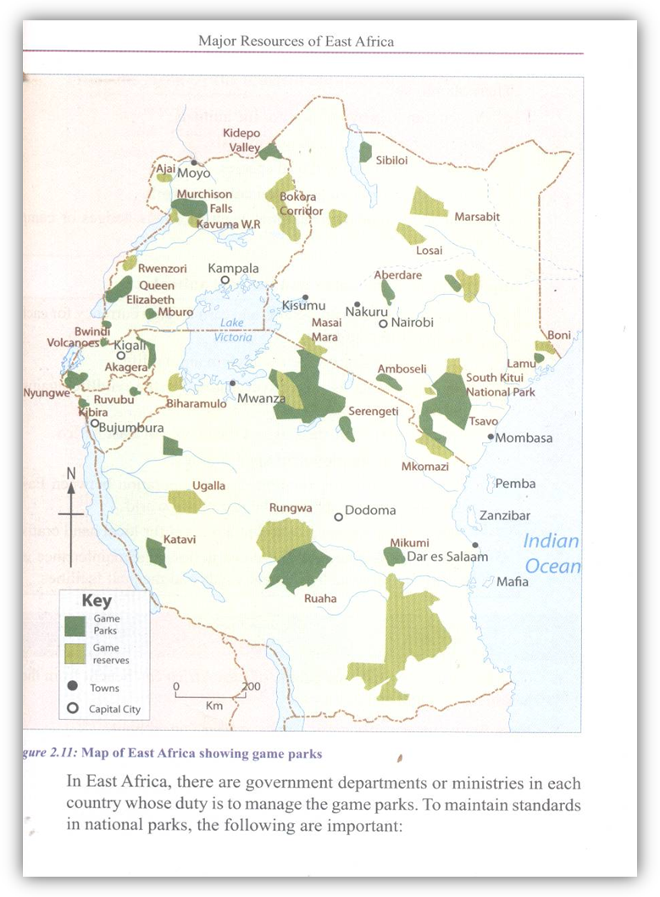

Importance of the tourism industry to the people of East Africa
- Employment is created
- Brings income to the government
- Promotes international cooperation
- Promotes the art and craft industry
- Promotes research and study
Problems faced by tourism industry
- Poor accommodation
- Poor transport
- Insecurity in some areas
- Low levels of advertisement of tourist centres
- Poaching
Solutions to the problems
- The government should construct better hotels
- The government should construct better roads that lead to tourist sites
- By improving security in the country
- By advertising through internet
- By enforcing strict laws against poaching
Disadvantages of tourism to a country to a country like Uganda
- It encourages the spread of diseases to both people and animals.
- Some of the tourists who come to visit come as spies which threaten the country’s security.

POACHING
- What is poaching?
This is the illegal hunting of wild animals in game parks
- Why do people carry out poaching?
- To get meat
- To get ivory from elephants
- To get hides and skins
- How is poaching dangerous to the tourism industry?
- It leads to extinction of rare animal species which reduces tourism
- It reduces the country’s revenue
- Why is tourism referred to as an industry?
- Why is tourism and electricity termed as invisible exports?
- Why is Kenya’s tourism industry more developed than that of Uganda?
- Kenya has better transport services than Uganda.
- Kenya has well developed accommodation facilities compared to Uganda.
- Kenya has more tourist attraction centres than Uganda.
- Kenya has a coastline while Uganda is landlocked.
- How Fort Jesus economically important to Kenya?

NOTE:
For Jesus was constructed by the Portuguese for protection.
Influence of vegetation on animal species
- Areas with thick forests attract climbing and fruit eating animals e.g. monkeys, apes, mountain gorillas etc.
- Swampy vegetation is suitable for amphibians
- Savanna attracts herbivores and carnivores e.g. elephants and lions.
- Semi-arid areas are suitable for small animals (rodents)

- Why is wildlife conservation important?
- To protect wildlife for future generations
- To protect the natural habitats for wild animals
- To promote tourism
- To create chances of employment
- To protect the natural beauty of our environment

- Under which ministry in Uganda is wildlife?
Ministry of Tourism, Wildlife and Antiquities

- Identify tourist attractions found in Kenya and Tanzania but not in Uganda.
- Indian ocean
- Coastal plains
- Mangrove swamps
- Sea ports
- Coastal beaches
- Coral reefs
- Oil refineries

The Common Animals Found in East Africa’s Game Parks
- Elephants, kobs, zebras, lions, leopards, monkeys, buffaloes, hippopotamuses, mountain gorillas, antelopes.
Country | National park | Major tourist attraction
Uganda | Murchison Falls N.P. | crocodiles
 | Kidepo Valley N.P. | ostriches
 | Lake Mburo N.P. | Zebras
 | - Mgahinga N.P.  - Bwindi N.P. | Mountain Gorillas
 | Queen Elizabeth N.P | Hippopotamuses/hippos
Kenya | Lake Nakuru N.P. | Flamingoes
 | Tsavo N.P. | Lions
Tanzania | Serengeti N.P. | Bush babies
Rwanda | Volcanoes N.P. | Mountain gorillas

Importance of vegetation in East Africa
- They provide timber for building and for furniture
- They are a source of wood fuel
- Forests help to conserve soil
- Forests are used for research and education purposes.
- Forests contribute to rain formation
- Forests are a source of herbal medicine.
- They provide employment opportunities for forest rangers, forestry offices.
- They provide a natural habitat for animals and birds.
- They provide fruits and food to people and animals.
- They attract tourists who bring income.
Ways people have destroyed vegetation
- By carrying out bush burning.
- By carrying out deforestation
- By draining swamps
Ways to preserve forests/vegetation
- By re-afforestation
- By afforestation/By planting trees.
- Through practicing agro-forestry.
- Through rural electrification.
- By enforcing laws against deforestation.
- By sensitizing people about the importance of forests and dangers of deforestation.
- Encouraging people to use alternative fuels other than wood.

Minerals
Vocabulary
- Minerals , exploit , petroleum , explosives
- Extraction , mineral ore , rocks , mining
What are minerals?
Minerals are valuable substances / materials in the ground.
Types of minerals in East Africa
- Metallic minerals e.g. iron ore, tin, aluminum, uranium, gold, manganese, copper, zinc
- Non-metallic minerals e.g. limestone, salt, sand, clay, diamonds, phosphates
- Fuel minerals e.g. coal, natural gas, crude oil

Different examples of minerals mined in East Africa
- Copper , limestone , diamond , phosphate , gold , tin , oil , iron ore , wolfram , salt , coal , soda ash , natural gas , clay , lead , sand , zinc , mica , fluorspar.

Activity
- Read about minerals in Fountain Book 6 pg. 86, 87
- To draw a map of East Africa showing mineral distribution.

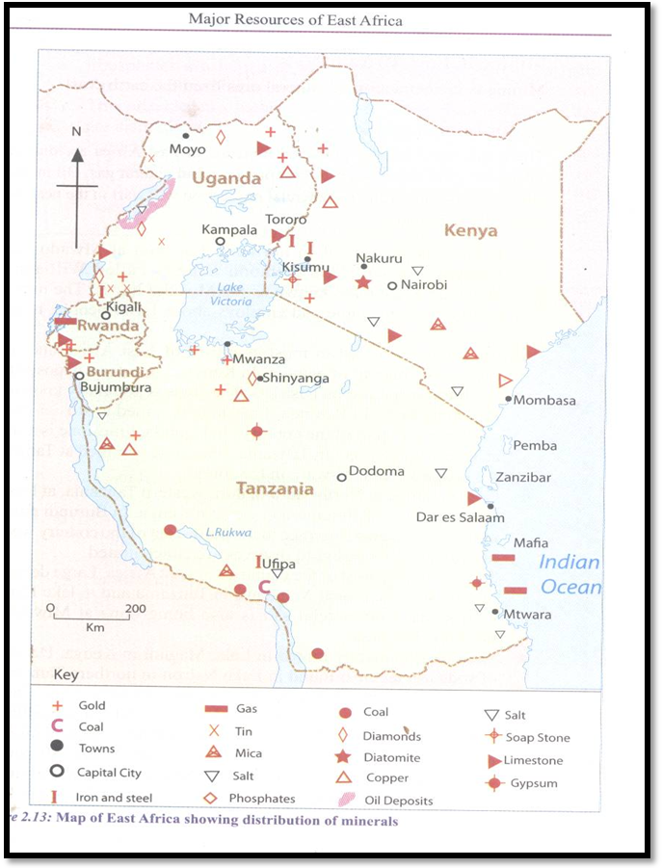
A map of East Africa showing distribution of minerals

Exercise
- Which mineral is mined at Hima in Uganda?
- Why was the fertilizer industry built in Tororo?
- Which mineral has been discovered at Lake Albert?

Mining
What is mining?
This is the extraction of minerals from underground.
Types of mining
Traditional methods of mining
- Panning:
It involves digging out sand from river beds and putting it on pans. It is used in gold mining.
- Scooping:
This involves removing / clearing unwanted materials and scooping the minerals using spades
Modern methods of mining
- Open cast method:
It is used in mining minerals e.g. limestone, diamonds, sand, clay. It is also used in extraction of minerals which are near the surface of the earth by clearing top soil, rocks and vegetation.
- Deep cast mining:
This is where minerals are extracted from underground by digging of shafts and tunnels e.g. copper
- Drilling:
This involves extracting minerals from underground using long pipes e.g. crude oil
- Alluvial mining:
This involves extracting minerals from alluvial soils or sand.
- Sub-marine mining:
This is the type of mining used to extract minerals found in the rocks at the bottom of seas.
Activity:
- Read about the methods of mining in the text book (Fountain S.ST 6 pg. 90)
- Observe tunnel mines and open cast mining on Pg. 90 – 91. (Fountain Book 6)
Exercise
- Mention two traditional methods of mining.
- Panning (ii) Scooping
- How do we call the extraction of minerals from underground?
Mining

- Which minerals are mined by drilling method?
Crude oil
- State the method of mining used to mine salt.
Panning

Location of minerals in East Africa
Mineral | Place | Product
Copper | Kilembe | Copper electric wires , bullet shell , TV screens
Gold | Karamoja (Moroto) Kakamega , Mubende | Gold medals, trophies, jewelry, watches, ornaments,
Cobalt | Kilembe - Kasese | Jet plane engines , surgical tools
Limestone | Hima in Kasese, Osukuru hills in Tororo | Cement, lime
Phosphates | Osukuru hills in Tororo | Artificial fertilizers
Crude oil | Lake Albert | Petrol , diesel , paraffin, plastics
Salt | Lake Katwe | Salt
Soda ash | Lake Magadi | Glasses
Diamonds | Shinyanga in Tanzania | Jewellery

Importance of mining in East Africa
- A source of income to the government / foreign exchange.
- A source of employment
- Produces raw materials used in secondary industries.
- Leads to the development of infrastructure.
- Leads to urbanization
- Promotes tourism in the country.
Disadvantages of mining in an area
- Leads to pollution
- Leads to land degradation
- Promotes soil erosion
- Leads to displacement of people.
- Accelerates landslides.
- May leads to loss of lives.
Solutions
- Government should enforce laws to minimize pollution of water.
- Mining companies should practice proper waste disposal
- Mining companies should get involved in afforestation and re-afforestation campaigns.
- Minerals should be used sparingly to avoid exhaustion.
Problems faced by the mining industry in Uganda
- Shortage of funds
- Poor machinery
- Shortage of skilled labour
- Flooding of mines
- Collapsing of mines
- Mineral exhaustion in an area
- Competition from other mineral producing countries
- Unreliable power supply
Solutions to the above problems
- Floods can be controlled by using draining machines.
- Poor technology and shortage of machinery can be solved by importing modern technology
- Shortage of funds can be solved by inviting foreign investors or borrowing money from foreign financial institutions.
- Power shortage can be reduced by setting up more small power stations.
- Shortage of skilled man power can be reduced by training more miners.

Activity
Read about mining on Pg. 91 – 92

Water Resources
- The water sources of East Africa include lakes, rivers, swamps, dams and the Indian Ocean.
Lakes in East Africa
Rift valley lakes in East Africa
Country | Lake
Uganda | Albert , Edward , George , Bunyonyi
Rwanda | Kivu , Bulera , Luhondo
Kenya | Turkana , Baringo , Nakuru , Elementaita ,Naivasha , Magadi , Bogoria
Tanzania | Natron , Manyara , Eyasi , Rukwa , Tanganyika , Malawi
Burundi | Tanganyika

Lakes found outside the rift valley
Uganda - Mburo, Kyoga, Bisina, Wamala, Nabugabo, Kwania,
Mutanda, Victoria
Kenya - Victoria, Amboseli
Rwanda - Mpangu, Ilema, Rweru
Burundi - Rweru, Tanganyika, Rugwero
Tanzania - Victoria, Sagara, Babati, Ikimba

Importance of lakes
- They are used for transport
- Source of minerals
- They provide water for irrigation
- They provide water for home use.
- They attract tourists who bring income.
- They provide water for irrigation
- They provide water for both home and industrial use.
- They act as fishing grounds
- They are a source of fish
- They act as recreation centres
Problems facing lakes
- Presence of water weeds/water hyacinth
- Disposal of wastes into lakes
- Drought which has led to decrease in water levels
- Silting
How can we help to protect our water bodies in East Africa?
- By not dumping waste materials in water bodies
- By using good methods of fishing
- By not clearing vegetation around water bodies
- By teaching people the importance of water bodies
- By planting trees around lakes
Activity
Draw a map of East Africa showing lakes and rivers.
Exercise
- Write down four rivers in each of the following East African countries.
Uganda ____, _____, ____, _____, _____
Kenya ____, _____, ____, _____, _____
Tanzania ____, _____, ____, _____, _____
Rwanda ____, _____, ____, _____, _____
Burundi ____, _____, ____, _____ , _____
- State the difference between seasonal rivers and permanent rivers.

Fishing
What is fishing?
Fishing is the catching of fish from water bodies.
Major fishing grounds in East Africa.
- Lakes –Victoria, Kyoga, Edward, George, Albert, Tanganyika, Malawi and Kivu
- Rivers – Nile, Katonga, Kagera, Rufigi, Kafu
- Swamps and wetlands especially on the shores of Lake Victoria and Lake Kyoga.
- Indian Ocean on the East African coastline

Activity: Children draw a map of East Africa showing fishing grounds

Types of fish caught in East Africa
There are many fish species caught in East Africa.
They include:-
- Nile perch - Mud fish
- Tilapia - cat fish
- Lung fish
Fishing Methods
There are two major types of fishing.
- Traditional method of fishing
- Modern method of fishing
The traditional method
- Use of traps
- Use of spears (harpooning)
- Use of baskets
- Use of herbs
Advantages of traditional methods of fishing
They are cheap to get and use.
Disadvantages of traditional methods of fishing
- Less fish is caught
- They are tiresome
- They can lead to fish indiscrimination e.g. use of herbs
Modern methods of fishing
- Gill netting
- Drifting method
- Trawling method
- Seining method
- Lining method
Advantages of modern methods of fishing
A lot of fish is caught.
Disadvantages of modern methods of fishing
They are expensive
Uses of fish
- It is a source of food
- It is used to make animal feeds.
- It is used in the manufacture of fertilizers
- It is used as a raw material
- It is a source of medicine
Activity
Learners observe pictures of fish and different fishing methods in Fountain pg. 95-99
Exercise
- a) Write down two modern methods of fishing.
b) State one advantage of using the above method of fishing
- Name the biggest type of fish caught in the lakes of East Africa.

Fish Preservation
Fish can be preserved using traditional or modern methods.
Traditional methods of preserving fish
- By smoking
- By salting
- By sun drying
Modern methods of preserving fish
- Refrigeration / freezing
- Canning/ Tinning
Importance of fishing to the people of East Africa
- Fishing provides food
- It provides jobs to people
- It promotes industrial development
- It is a source of raw materials
Problems facing the fishing industry
- Poor methods of fishing.
- Poor transport network.
- Lack of modern fishing tools.
- Attacks from dangerous marine animals.
- Water weed/water hyacinth.
- Shortage of storage facilities.
- Unfavorable climatic conditions/Storms.
- Draining of swamps and wetlands.
Give two examples of poor fishing methods used in East Africa.
- Fish poisoning
- Over fishing
- Using undersized nets
Solutions to the problems facing fishing industry
- Use of modern methods of fishing
- By regulating the selling of fishing nets
- Construct roads to the fishing grounds to transport fish.
- Control water pollution
- Promote conservation of wetlands and swamps
Activity
Learners read Fountain Book 6 pg. 97 – 99
Using the atlas to identify the major fishing grounds in East Africa

Transport and Communication in East Africa
Vocabulary
- The internet - landlines
- E-mail - mobile / cell phones
- Fax

Communication in East Africa
What is communication?
Communication is the sending and receiving of messages / information.
Traditional means of communication
- Drums - messengers / heralds
- Alarms - rock pictures
- Smoke - trumpets
- Whistles - horns
- Signals
Challenges of traditional means of communication
- They are slow
- They have a small coverage
- They are not easy to interpret

Activity: Children draw and name traditional means of communication

Modern means of communication
- Phones - Televisions - letter writing
- Radios - internet - telegrams
- Magazines - fax machine
Challenges of modern means of communication
- The postal service sometimes suffers from delays and theft
- Some give false information
- Fixed telephone lines can be easily damaged by rain, wind and storms
- They are expensive to use.
- They cannot easily be used by the illiterate
- Some expose pornography to the public

Forms of modern communication
Mass media
- What is mass media?
This is communication which provides the information to very many people at the same time
- Examples of means of mass media;
- Radio - Newsletter - Magazines
- Newspapers - Television

Telecommunication
It involves using the following during communication i.e. Telephones, Telex, radio calls etc.
Advantages of using a radio
- Used for advertisements
- It is cheap
- It provides jobs to people
- It is a source of government revenue
- Used for entertainment
- Used for study purposes through education programmes
- Provide information through broadcasting news
- They can be used by the illiterates

Disadvantages of using a radio
- Radio network signals do not reach distant places
- The deaf can’t use radios
- Some programmes teach immoral behaviour

Advantages of news papers
- They provide detailed information
- Can be kept for future references / record purposes
- They are used for advertisement
- They are a source of educative information
- They provide stories for entertainment.
Disadvantages of newspapers
- They are expensive to buy
- The illiterate do not benefit
- They sometimes give wrong information
- Take too long to reach remote areas
- Some newspapers portray pornography.
List of some of the newspapers found in Uganda
- Bukedde - The Observer
- The New Vision - Rupiny
- The Red pepper - Orumuri
- The Daily Monitor -The East African
- Etop
Examples of government owned Newspapers
- Bukedde -The New vision
- Etop - Orumuri
Examples of private owned newspapers in Uganda
- The Daily monitor - The East African
Activity: Children draw any three modern means of communication

Exercise
- How important are newspapers and radio stations in the development of the country?
- They create employment opportunities
- They promote communication
- Increases on government’s revenue
- They promote trade through advertisement
- Give the advantages of using a television
- It is audio-visual
- It is used for entertainment
- It helps us to access information which may be inaccessible.
- It is effective in advertising
- Provides programmes which are educative.
- State the disadvantages of a television.
- Television sets are expensive to buy
- It requires electricity to operate
- Transmits information in few languages
- Some programmes promote immorality
- State the advantages of using telephones.
- They give firsthand information
- Telephones are very fast
- They serve a number of purposes e.g. telling time, accessing internet, sending short messages, money transfers
- They stores messages
- State the disadvantages of using telephones
- They are expensive to buy and maintain
- Poor network in distant places
- It depends on electricity for charging
- State the roles of a post office in our community.
- To send letters and parcels to owners.
- Sell postage stamps
- Provides employment opportunities to people.
- Provides telephone services.
- Give one example of;
- Print media:
- Electronic media:

Challenges Facing Communication in East Africa
- Modern means of communication are expensive.
- Presence of some physical features that block communication signals.
- Some people are illiterate
- Electricity is not available in all regions
- Poverty
Solutions
- Supplying electricity in the whole country.
- Construction of boosters to improve communication net work.
- Constructing communication facilities in rural areas.
- Many people should have access to education
Exercise
- Write down one benefit of using a radio.
- State two forms of traditional means of communication that are still being used today.
- Give two disadvantages of traditional means of communications.
- Give two reasons why few people in East Africa use the internet.
- Give two ways of sending information today.
- Name two ways through which people in rural areas of East Africa get information.
- Give two services provided by the post office.
- Write UCC in full.
- Under which ministry are radios and Televisions in Uganda?
Ministry of ICT and National Guidance

Transport Services in East Africa
What is transport?
Transport is the movement of people and goods from one place to another.
Importance of transport
- It promotes trade
- It promotes tourism
- It promotes communication
- It links urban areas to rural areas
Traditional means of transport
Animals, dhows, logs, canoes, rafts, foot
Modern means of transport
Cars, buses, lorries, aero planes, helicopters, jets, ferries, ships, trains
Disadvantages of traditional means of transport
- They are slow
- They are exposed to high risks of accidents
- They carry limited goods and passengers
- They are not durable.

Types of transport
- Road transport
- Railway transport
- Water transport
- Air transport
- Pipeline transport.

Road transport
This is the oldest type of transport
Means of road transport
- cars, lorries , bicycles , buses , horses / camels
Traditional means of road transport
- Foot.
- Animal transport e.g. camels, donkeys.
- stretchers
Advantages of road transport
- It is common
- It is cheaper for shorter distances
- It offers door-to-door services
- It has many means of transport

Challenges / disadvantages of road transport
- Road transport vehicles are easy targets for highway robbery.
- Roads are expensive to maintain
- Murram roads become muddy and slippery during the rainy season.
- There are many accidents on the road.
- It is affected by traffic jam
Solutions to the above challenges
- Strict implementation of traffic rules.
- Improving road construction standards
- Maintaining and repairing roads regularly
- Implementing weight limit of vehicles
- Offering traffic education to drivers

Exercise:
- State the common causes of accidents
- State the difference ways people in East Africa can control road accidents
- How important is road safety education?
- On which side of the road should pedestrians move?
- Why are the following important to road users?
- Zebra-crossing: It helps pedestrians to cross busy roads safely.
- Speed governors: To control the speed limit of vehicles.
- Seat belts: For protection in case of an accident.
- Helmet: To protect the head of a motorcyclist in case of an accident.

Railway Transport
- The first railway line in East Africa was Tanga – Korogwe railway line built by Germans in Tanganyika in 1893.
- The Uganda railway was started at Port Mombasa in Kenya in 1896 and ended in Pakwach in Uganda in 1965.
- The Tazara railway was built in 1970 to link Zambia to the coast so that copper could be transported easily to the coast.
- Another name for TAZARA is Tanzam railway.
Mention the governments responsible for the construction of each the railway lines below;
-Tanga - Korogwe railway –The Germany government.
-Uganda railway - The British government.
-TAZARA / Tanzam railway – The Chinese / Zambian governments.

Reasons for the construction of the Uganda railway
- To stop slave trade
- To promote trade in the region
- To make transport easy
- To link Uganda to the coast
- To make British administration easy
- What contribution was made by each of the following
- Sir William Mackinnon
- He proposed the idea of the construction of the Uganda railway.
- George Whitehouse
- He was the chief engineer during the construction of the Uganda railway.
- Major Macdonald
- He surveyed the area where the railway line was going to pass.
- Colonial Patterson
- He killed man eaters at the last inspection of the Uganda railway.

State the effects/results of construction of the Uganda railway.
- Transport was made easy
- Uganda was linked to the coast
- Slave trade was stopped
- The Uganda Railway promoted trade
- It made British administration easy
How did the construction of the Uganda railway help to stop slave trade?
They started using trains for transport instead of slaves.
Mention problems faced by the builders of Uganda railway
- Attacks from hostile tribes e.g. Masai and Nandi
- Shortage of labour
- Attacks from man eaters at Tsavo/ Voi National Game Park
- Harsh climatic conditions in some areas
- Difficult to cross highlands, the rift valley, rivers and wetlands
Why was railway network extended to the following areas?
- Pakwach – Transport tobacco from Pakwach
- Namasagali – To transport cotton to Jinja
- Kasese – To transport copper from Kilembe to Jinja for smelting

State the contributions of the Indian Community in the development of East Africa.
- They built the Uganda Railway
- They developed towns in East Africa
- They built shops
- They introduced the Indian Rupees
- They built industries and factories
- They promoted agriculture through setting up large plantations in East Africa
How was the problem of labour shortage solved during the construction of the Uganda railway?
Which group of people was brought to construct the Uganda railway?
Why did Africans refuse to provide labour during the construction of the Uganda railway?
Why was the construction of the Uganda railway not extended from Kasese to DRC?
What problems were faced by the railway builders at?
(i) Voi:
(ii) Nakuru:
How was the rift valley a problem during the construction of the Uganda railway?
How did the following affect the construction of the Uganda railway?
(i) The rift valley:
(ii) The Nandi:
(iii) The lions at Tsavo:
Which town in East Africa was developed into a city as a result of the construction of the Uganda railway?
Why is railway transport not commonly used in East Africa today?

Activity
- Find out the goods that are transported by the train to Port Mombasa.
- Children draw a train.
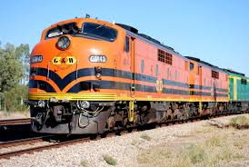
Advantages of railway transport
- It is the best for carrying heavy and bulky goods.
- It is not easily affected by bad weather.
- It works on a fixed timetable making it reliable.
- It is cheaper than road and air transport.

Disadvantages of railway transport
- It is expensive to construct and maintain
- Trains do not offer door-to-door services.

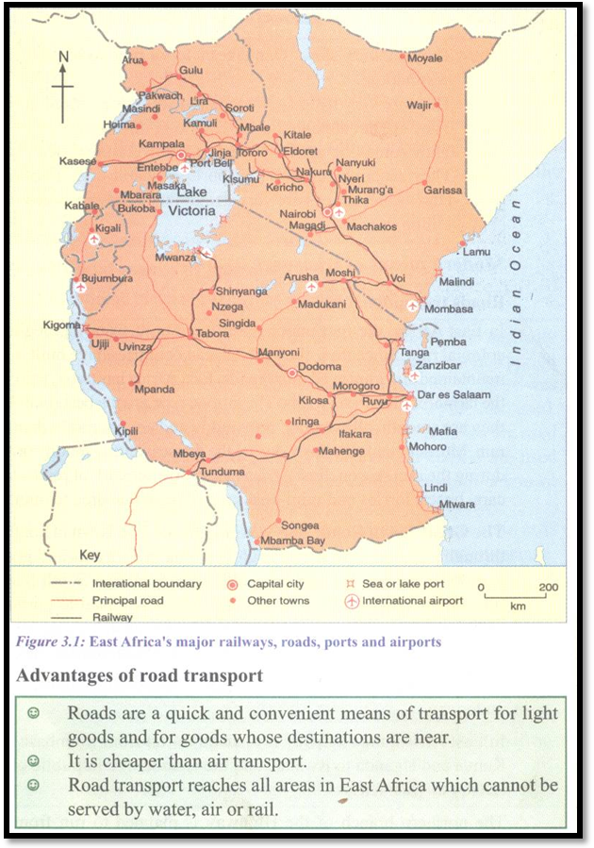
A map showing transport network in East Africa

Air Transport
Advantages of air transport
- It is very fast over long distance
- Air transport is comfortable
- It is reliable and convenient as it keeps a fixed time table
- It can’t be hindered by most physical features
- It can be used to save people’s lives during natural or man created disasters

Disadvantages of air transport
- It is very expensive
- It can be affected by bad weather conditions
- Air crushes are fatal
- It is not common

Which body controls all flights in Uganda?
The Civil Aviation Authority (CAA)

Water Transport
- It is the cheapest of all means of transport.
- It is the best type of transport for transporting delicate goods.
Disadvantages of water transport
- It is slow
- It is expensive to construct and maintain ports.
- Ships, boats and steamers can have accidents caused by rocks and storms.
- Waterfalls and rapids hinder water transport on rivers.
- It can be hindered by floating vegetation.

Pipeline transport
This involves the transportation of liquids and gases from one place to others using pipes, e.g. water, petroleum products, sewage
Advantages of pipeline transport
- It minimizes transport costs for oil products.
- It involves no accidents.
- It minimizes wastage of fuel to transport oil products from one place to another.
- It does not disrupt other activities.
Disadvantages of pipeline transport
- The cost of constructing pipelines is very high.
- It is expensive to repair if there is leakage.
- It is very difficult to construct pipelines in mountainous areas.
- It can’t be used to transport solid commodities.
Problems facing transport in East Africa
- Modern means of transport like roads, railways, airports are expensive to construct.
- Road and water transport have experienced frequent accidents leading to loss of lives.
- Heavy rains have destroyed some roads and made them impassable.
- Water weeds on water bodies.
- Traffic jams in major cities.
- Air flights and passenger fares are high.
- It is expensive to purchase railway wagons, ferries, ships and aeroplanes.
Solutions to the problems
- Undertaking joint projects to build roads, railways and ports.
- Implementing roads and marine safety rules and guidelines to reduce accidents.
- Putting in more effort to reduce the water hyacinth.
- Improving security through joint operations
- Controlling overloading by enforcing axle load weight limits.
- Sensitizing drivers on the importance of observing traffic rules.
- Building by-passes, flyovers and under passes to reduce traffic jams.
Activity: Children discuss the problems facing transport and solutions.

